Name: SWETHA S J
Dept/Sec: CCE –A
Roll no – SIT22CO051
Regno - 412422118051
Assignment - 1

1. Explain the concepts of 5G spectrum access modes in detail.
2. Explain in detail about the basics about RAN architecture and high-level requirements for 5G architecture ?
3. Evaluate the Sparse Code Multiple Access (SCMA) technique by comparing it with other non-orthogonal multiple access (NOMA) schemes.

Answers

5G Spectrum Access Modes

5G Spectrum Access Modes
- Current radio regulations provide four frequency band classifications: Exclusive bands, Shared bands, License-free bands, and Receive-only bands.
- Two service categories, Primary service and Secondary service are defined on the basis of ITU-R allocations in the regions.
- Multiple frequency bands, subject to different regulatory regimes including various forms of shared spectrum concepts as illustrated in Figure , are expected to be available for mobile communication systems.
- Thus, 5G system design requires a high degree of flexibility to be capable of operating under different regulatory models and usage scenarios.
- In general the use of radio spectrum can be authorized in two ways: Individual
- Authorization (Licensed) and General Authorization (License Exempt or Unlicensed). Authorization modes recognized as relevant for wireless communications are Primary user mode, LSA mode and Unlicensed mode.
- Five basic spectrum usage scenarios are identified in Figure for these authorization modes: dedicated licensed spectrum, limited spectrum pool, mutual renting, vertical sharing, and unlicensed horizontal sharing.
- The figure depicts the relationship between parts of the domains that are either necessary or supplementary, using solid and dotted lines respectively.
- More complex spectrum usage scenarios can be supported by combinations of the basic scenarios and authorization modes

Introduction
- Spectrum refers to radio frequency bands used for wireless communication.
- 5G requires flexible and efficient spectrum usage.
- It supports high data rate, low latency, and massive connectivity.
- Traditional licensed spectrum alone is not sufficient for 5G.

Need for Spectrum Access Modes
- Rapid increase in mobile data traffic.
- Large number of connected devices.
- Limited availability of licensed spectrum.
- Requirement for private and enterprise networks.
- Need for efficient spectrum utilization.

Types of 5G Spectrum Access Modes
- Licensed spectrum access.
- Unlicensed spectrum access.
- Shared spectrum access.
- Dynamic spectrum access.

- Licensed Spectrum Access
- Spectrum is exclusively allocated to a network operator.
- License is issued by government regulatory authorities.
- Provides guaranteed quality of service.
- Offers high reliability and security.
- Experiences very low interference.
- Licensing cost is very high.
- Mainly used for public 5G networks.
- Suitable for mission-critical applications.

Unlicensed Spectrum Access
- Spectrum can be used without exclusive licensing.
- Multiple technologies share the same frequency band.
- Commonly operates in ISM bands.
- Uses Listen Before Talk mechanism to avoid interference.
- Does not guarantee quality of service.
- Has higher interference compared to licensed spectrum.
- Deployment cost is low.
- Mainly used for indoor and enterprise networks.

Shared Spectrum Access
- Spectrum is shared among multiple users based on priority rules.
- Access is controlled through predefined sharing mechanisms.
- CBRS band is a common example of shared spectrum.
- Uses tier-based access structure.
- Managed by Spectrum Access System (SAS).
- Improves spectrum efficiency.
- Cost is lower than licensed spectrum.
- Used for private and industrial 5G networks.

Dynamic Spectrum Access
- Spectrum is allocated dynamically based on availability.
- Users access spectrum only when it is unused.
- Uses real-time spectrum sensing techniques.
- Based on cognitive radio technology.
- Maximizes spectrum utilization.
- Reduces spectrum wastage.
- Implementation is complex.
- Suitable for dense network environments.

Advantages of Multiple Spectrum Access Modes
- Efficient utilization of available spectrum.
- Support for diverse 5G applications.
- Reduced dependency on licensed spectrum.
- Enables private and enterprise deployments.
- Improves overall network flexibility.
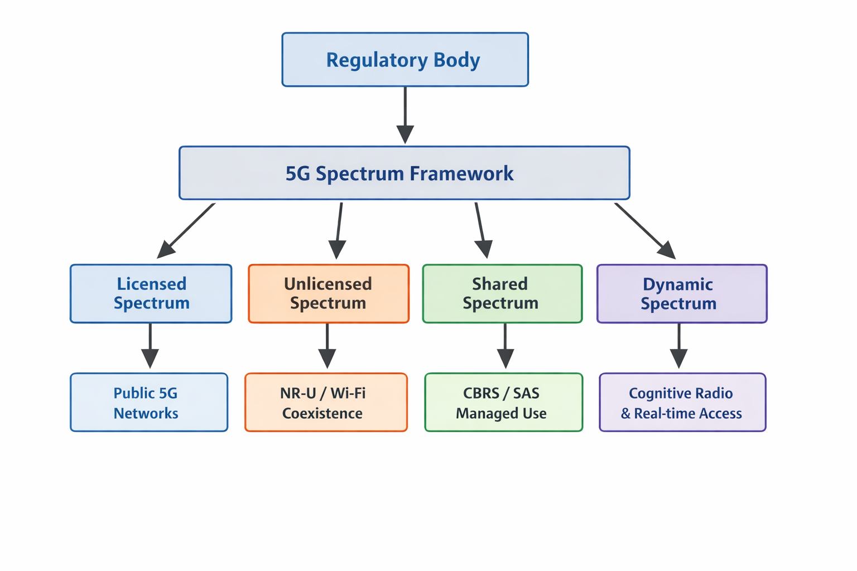

- Basics of RAN Architecture and High-Level Requirements of 5G Architecture
1. INTRODUCTION
- Network Architecture integrates technical components into a unified system
- Ensures interoperability between different manufacturers.
- Logical architecture consists of Network Elements (NEs), interfaces, and protocols.
- Standardized interfaces define procedures, messages, and behavior.
- The design of network architectures aims firstly at integrating technical components into an overall system and making them properly interoperable.
- In this context, it is very important to define a common understanding on how components designed by different manufacturers are capable of communicating so that they can execute the needed functionalities.
- So far in standardization, this common understanding is achieved by the specification of a logical architecture consisting of logical Network Elements (NEs), interfaces and related protocols.
- Standardized interfaces allow for communication between NEs with aid of protocols including procedures, message formats, triggers and behavior of the logical network elements.
2. BASICS OF RAN ARCHITECTURE
• RAN connects User Equipment (UE) to the Core Network.
• Responsible for radio resource management and mobility.
• In 5G it is called NG-RAN.
• RAN connects User Equipment (UE) to the Core Network.
• It is responsible for radio resource management, mobility management, and data transmission.
• In 5G, RAN is referred to as NG-RAN (Next Generation RAN).
3. KEY COMPONENTS OF 5G RAN
• User Equipment (UE): Mobile device used by the end user.
• gNodeB (gNB): 5G base station that communicates with UE.
• Central Unit (CU): Handles higher-layer protocols such as PDCP and RRC.
• Distributed Unit (DU): Handles real-time MAC and PHY functions.
• Radio Unit (RU): Performs RF processing and transmission..
4. FUNCTIONAL ARCHITECTURE
• Network Functions (NFs) perform operations.
• Each NF is mapped to a Network Element.
• Different NFs have different latency and bandwidth needs.
5. PHYSICAL ARCHITECTURE
• Physical Architecture maps NEs and NFs to physical nodes.
• Placement impacts network performance and network economics.
• Centralized Placement supports statistical multiplexing.
• Distributed Placement reduces latency near the air interface.
6. ROLE OF SDN AND NFV
• Network Function Virtualization (NFV) virtualizes network functions.
• Software Defined Networking (SDN) separates control and data planes.
• Enables flexible placement and dynamic orchestration of NFs.
• 5G focuses more on Network Functions than Network Elements
7. HIGH LEVEL REQUIREMENTS OF 5G
• Enhanced Mobile Broadband (eMBB): High data rates and capacity.
• Ultra-Reliable Low Latency Communication (URLLC): Low latency and high reliability.
• Massive Machine Type Communication (mMTC): Supports IoT devices.
• Low Latency: End-to-end latency below 1 ms.
• High Reliability: 99.999% availability.
• Scalability: Supports massive number of users and devices.
• Flexibility: Dynamic network slicing and service deployment.
• Energy Efficiency: Reduced power consumption.
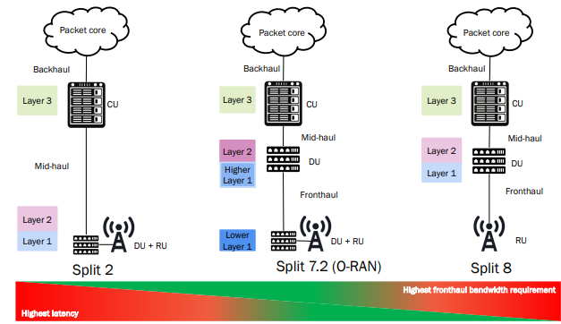

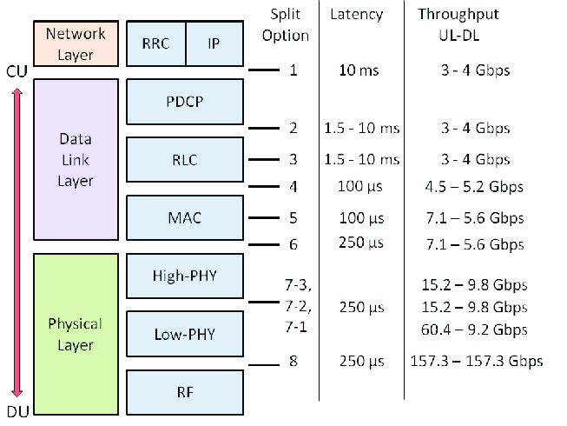

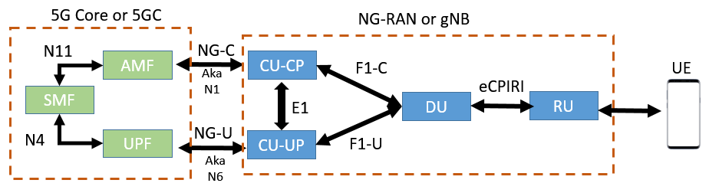

- Evaluation of Sparse Code Multiple Access (SCMA) and Comparison with Other NOMA Schemes

1. Introduction to NOMA
With the evolution of 5G and beyond (B5G/6G) networks, traditional Orthogonal Multiple Access (OMA) techniques such as TDMA, FDMA, CDMA, and OFDMA are insufficient to meet requirements like:
- Massive connectivity
- Low latency
- High spectral efficiency
- Support for IoT and mMTC
To overcome these limitations, Non-Orthogonal Multiple Access (NOMA) schemes were introduced, allowing multiple users to share the same time-frequency resources.
Sparse Code Multiple Access (SCMA) is one of the most promising code-domain NOMA techniques.

2. What is Sparse Code Multiple Access (SCMA)?
SCMA is a non-orthogonal, code-domain multiple access technique where:
- User data is directly mapped to multi-dimensional sparse codewords
- Multiple users share the same time–frequency resources
- Overloading is supported (users > resources)

Key Idea
Each user is assigned a unique sparse codebook, and only a few resource elements (REs) are used by each codeword → reducing interference.

3. SCMA Transmitter and Receiver Operation

3.1 Transmitter Side
- Input bits are taken from each user
- Bits are directly mapped to sparse codewords
- Codewords are spread across multiple subcarriers
- Signals from multiple users are superimposed

3.2 Receiver Side
- Uses Message Passing Algorithm (MPA)
- Exploits sparsity of codebooks
- Performs near-optimal multi-user detection with low complexity

4. Sparse Nature of SCMA
- Each codeword has many zero elements
- Only a few subcarriers are active per user
- Leads to:
  - Reduced inter-user interference
  - Lower detection complexity
  - Efficient resource utilization

5. Advantages of SCMA

5.1 High Spectral Efficiency
- Supports overloading factor > 100%
- More users served per resource block

5.2 Massive Connectivity
- Ideal for IoT and mMTC
- Large number of users can be connected simultaneously

5.3 Low Latency
- Grant-free access possible
- Suitable for URLLC applications

5.4 Improved Detection Performance
- MPA provides near-maximum likelihood performance
- Better BER compared to other NOMA schemes

5.5 Robust to Noise and Interference
- Multi-dimensional modulation improves reliability

6. Limitations of SCMA
- Complex codebook design
- Higher receiver complexity than OMA
- Performance depends heavily on optimized MPA implementation

8. Applications of SCMA
- 5G New Radio (NR)
- Massive Machine Type Communication (mMTC)
- Internet of Things (IoT)
- Ultra-Reliable Low Latency Communication (URLLC)
- Smart cities and Industry 4.0
Sparse Code Multiple Access (SCMA) is a powerful code-domain NOMA technique that enables:
- Massive connectivity
- High spectral efficiency
- Low latency communication
Compared to other NOMA schemes such as PD-NOMA, LDS-CDMA, and MUSA, SCMA offers better performance, reduced interference, and improved reliability, making it a strong candidate for 5G and future wireless systems.

